
A 10
SET NO : 1

Sreenidhi Institute of Science & Technology
(An Autonomous Institution)
Code No: 101MA03/111MA03
B. TECH. I – Year II – Semester Examinations, June/July, 2012 (Regular/Suppli.)
MATHEMATICS - II (Common to EEE,ECE,ECM)

Time: 3 Hours Max. Marks : 70

Note : No additional answer sheets will be provided.

Part-A (Objective Type)
Max.Marks:20

Answer all QUESTIONS.

1. Define exact differential equation. Write the condition for a differential equation f(x,y)dx+g(x,y)dy=0 to be exact.

2. Obtain the differential equation of the family of straight lines having non zero intercepts on the coordinate axes.

3. Find the particular integral of (D²+16)y=sin4x.

4. Find the Laplace transform of the differential equation 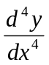=sin x, given that y and all the derivatives of y up to 3rd order vanish at the origin.

5. If the Z-transform of 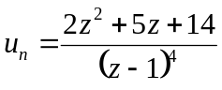, then find u₀.
6. State convolution theorem of Laplace transforms.

7. Find the directional derivative of φ(x,y)=x²+y² at the point (1,-1,2) in the direction of vector 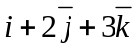.
8. Find curl(grad f).

9. Define Wronskain of two functions. Find Wronskain of x and x²-1.
10. If f(x)=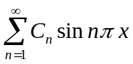, then write C_{n}.
Part – B
Max. Marks: 50

ANSWER ANY FIVE QUESTIONS. EACH QUESTION CARRIES 10 MARKS.

1. a) Solve the logistic equation 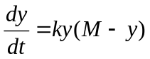, assuming that k>0, 0≤y≤M with initial condition y(0)=1.

b) Solve 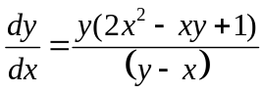.

2. a) Solve (D²-1)y=x Sinx + x²e^{x}. [ 5 ]

b) Solve 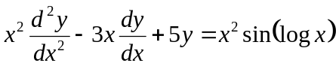. [ 5 ]

3. a) Solve the simultaneous equations 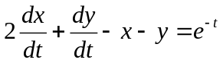; 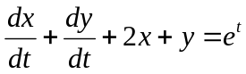 that x(0)=2, y(0)=1. [ 5 ]

b) Find the inverse Laplace transform of 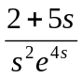. [ 5 ]
4. a) Find the angle of intersection of the spheres x²+y²+z²=29 and [ 5 ]
x²+y²+z²+4x-6y-8z=47 at (4,-3,2)

b) Find the Fourier series of 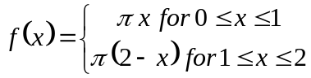 in interval (0,2).
[ 5 ]
5. a) Find the Fourier series of the function f(x)=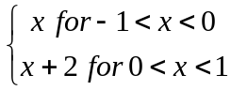 [ 5 ]
and hence deduce that 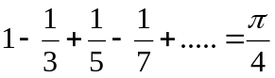.
b) Find the half range cosine series of f(x)=Sinx in the internal 0<x<π. [ 5 ]

6. a) Solve the difference equation U_{n}=U_{n-1}+U_{n-2} using Z-transforms. Given that U₀=U₁=1. [ 5 ]

b) State final value theorem of z-transforms and by using this theorem to find u∞, given that 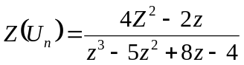. [ 5 ]

7. Verify Gauss divergence theorem for the vector function 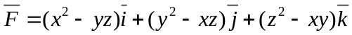 along the surface of the parallelopiped bounded by x=0, x=a, y=0, y=b, z=0 and z=c.

8. a) State convolution theorem of Laplace transforms. Use this theorem to evaluate the inverse Laplace transform of 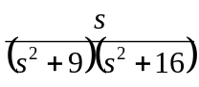. [ 5 ]
b) Find the inverse Laplace transform of 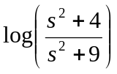. [ 5 ]
-- 00 -- 00 --

